|  |  |
| --- | --- |
| **Total Git Repository Commits:** | **195 commits** |
| Kevin | 94 commits |
| Samuel | 47 commits |
| Trent | 11 commits |
| Josh | 27 commits |
| Eric | 16 commits |

GIT Analysis:

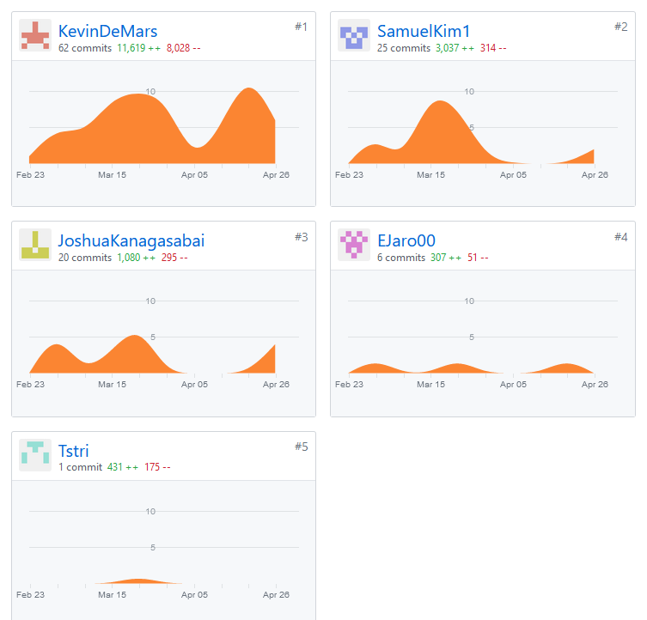

Commits minus merges: